I live in the Lincoln Square neighborhood of Chicago and frequently visit a local taqueria for Mexican food. In the summer, the restaurant is especially busy with kids and families who participate in little league baseball at Welles Park, just across the street.

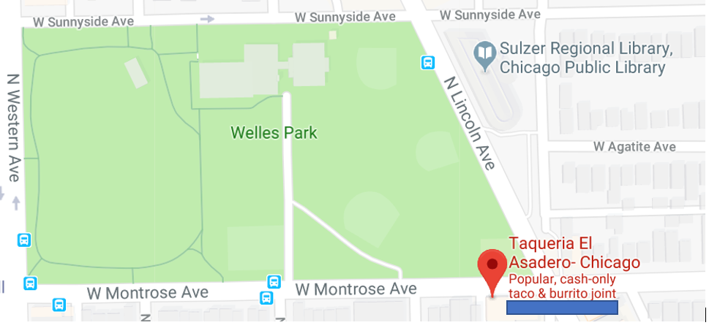

People have claim that 9 out of 10 restaurants fail within the first year of opening. One of the major reasons is location, if potential customers cannot easily visit a restaurant they will patron another more convenient option. Nielsen reports there are over 22,000 restaurants in Chicago.[1] Chicagoans have plenty of delicious options to choose from for food.

Using techniques from IBM Data Science Coursework, I want to identify the types of businesses to open near Chicago public baseball fields.

1. <https://www.nielsen.com/content/dam/corporate/us/en/public%20factsheets/restaurant-growth-index.pdf>